**SYDNEY WESTERN CITY PLANNING PANEL ASSESSMENT REPORT**

|  |  |
| --- | --- |
| Panel Number: | PPSSWC-247. |
| Application Number: | 2022/507/1. |
| Local Government Area: | Camden. |
| Development: | Construction of a mixed use development comprising sixty-three (63) light industry units, self-storage premises, a centre-based child care centre for eighty (80) children, takeaway food and drink premises, ancillary manager's office, car parking, signage, landscaping and associated site works |
| Capital Investment Value: | $30,654,837 |
| Site Address(es): | 36 Turner Road, Smeaton Grange |
| Applicant: | Mr G Antoniou |
| Owner(s): | Walkway Properties Pty Ltd |
| Date of Lodgement: | 27 May 2022 |
| Number of Submissions: | None |
| Number of Unique Objections: | None |
| Classification: | Regionally significant development. |
| Recommendation: | Approve with conditions. |
| Regional Development Criteria (Schedule 7 of State Environmental Planning Policy (State and Regional Development) 2011): | General development capital investment value >$30 million. |
| List of All Relevant Section 4.15(1)(a) Matters: | * State Environmental Planning Policy (Planning Systems) 2021. * State Environmental Planning Policy (Transport and Infrastructure) 2021. * State Environmental Planning Policy (Resilience and Hazards) 2021. * State Environmental Planning Policy (Industry and Employment) 2021. * State Environmental Planning Policy (Biodiversity and Conservation) 2021. * Education and Care Services National Regulations (2011 SI 653) * Camden Local Environmental Plan 2010. * Camden Development Control Plan 2019. |
| List all Documents Submitted with this Report for the Panel’s Consideration: | * Assessment report. * Applicant’s written request seeking to justify the contravention of a development standard. * Camden Local Environmental Plan 2010 assessment table. * Camden Development Control Plan 2019 assessment table. * Child Care Planning Guideline (2021) assessment table * Recommended conditions. * Proposed plans. |
| Development Standard Contravention Request(s): | * Camden Local Environmental Plan 2010. * Clause 4.3 - Height of buildings. |
| Report Prepared By: | Averil Flaxman (Senior Town Planner) |
| Report Date: | December 2022. |

**Summary of Section 4.15 Matters**

|  |  |
| --- | --- |
|  | **Yes** |
| Have all recommendations in relation to relevant Section 4.15 matters been summarised in the Executive Summary of the assessment report? |  |

**Legislative Sections Requiring Consent Authority Satisfaction**

|  |  |
| --- | --- |
|  | **Yes** |
| Have relevant sections in all applicable environmental planning instruments where the consent authority must be satisfied about a particular matter been listed and relevant recommendations summarised in the Executive Summary of the assessment report? |  |

**Development Standard Contraventions**

|  |  |  |
| --- | --- | --- |
|  | **Yes** | **N/A** |
| If a written request for a contravention to a development standard has been received, has it been attached to the assessment report? |  |  |

**Special Infrastructure Contributions**

|  |  |  |
| --- | --- | --- |
|  | **Yes** | **No** |
| Does the application require Special Infrastructure Contributions? |  |  |

**Conditions**

|  |  |
| --- | --- |
|  | **Yes** |
| Have draft conditions been provided to the applicant for comment? |  |

**PURPOSE OF REPORT**

The purpose of this report is to seek the Sydney Western City Planning Panel’s (the Panel’s) determination of a development application (DA) for the construction of a mixed use development comprising sixty-three (63) light industry units, self-storage premises, a centre-based child care centre for eighty (80) children, takeaway food and drink premises, ancillary manager's office, car parking, signage, landscaping and associated site works at 36 Turner Road, Smeaton Grange.

The Panel is the consent authority for this DA as the capital investment value (CIV) of the development is $30,654,837. This exceeds the CIV threshold of $30 million for Council to determine the DA pursuant to Schedule 7 of State Environmental Planning Policy (Planning Systems) 2021.

**SUMMARY OF RECOMMENDATION**

That the Panel determine DA/2022/507/1 for the construction of a mixed use development pursuant to Section 4.16 of the *Environmental Planning and Assessment Act 1979* by granting consent subject to the conditions attached to this report.

**EXECUTIVE SUMMARY**

Council is in receipt of a DA for the construction of a mixed use development comprising sixty-three (63) light industry units, self-storage premises, a centre-based child care centre for eighty (80) children, takeaway food and drink premises, ancillary manager's office, car parking, signage, landscaping and associated site works at 36 Turner Road, Smeaton Grange.

The DA has been assessed against the *Environmental Planning and Assessment Act 1979*, the *Environmental Planning and Assessment Regulation 2021*, relevant environmental planning instruments, development control plans and policies.

A summary of the assessment of all relevant environmental planning instruments is provided below with a detailed assessment provided later in the report.

|  |  |
| --- | --- |
| State Environmental Planning Policy (Planning Systems) 2021. | The Panel is the consent authority for this DA as the development has a CIV of $30,654,837 which exceeds the CIV threshold of $30 million for Council to determine the DA. |
| State Environmental Planning Policy (Transport and Infrastructure) 2021 (Transport and Infrastructure SEPP). | The DA was referred to Endeavour Energy for concurrence as the proposed development is within 5m of an exposed overhead electricity power line. Endeavour Energy has provided recommended conditions of consent.  Consideration of the Child Care Planning Guidelines in relation to the proposed development has been provided and is attached to this report.  Additional consideration has been made to the proposed child care centre being located in an industrial zone which is discussed later in this report. |
| State Environmental Planning Policy (Resilience and Hazards) 2021 (Resilience and Hazards SEPP). | Council staff have assessed a Phase 2 Detailed Site Investigation (contamination) determining the site is suitable for a commercial/industrial use. The Phase 2 assessment did however identify one area that would require re-evaluation should a more sensitive land use be proposed. A data gap analysis was conducted which included additional test pits over the site. The contaminant levels found previously were unable to be replicated and no indications of gross contamination was identified in any other locations on site.  Based on sampling for the data gap analysis and previous investigations the data gap analysis concluded the site in its entirety is suitable for the proposed use as commercial/industrial and for a child care centre at the proposed location. Council staff are satisfied the site is suitable for the proposed development. |
| State Environmental Planning Policy (Industry and Employment) 2021 (Industry and Employment SEPP). | The applicant is seeking consent for the construction of the pylon sign structures at both entry points to the site. The application seeks indicative consent for the location of the other signage throughout the site. An assessment of the proposed signage has not been undertaken as the proposed signage plans lack the required information for a complete assessment. A condition of consent is recommended requiring any proposed signage on site to comply with the requirements of the State Environmental Planning Policy (Exempt and Complying Development Codes) 2008 or alternatively a further development application will be required. |
| State Environmental Planning Policy (Biodiversity and Conservation) 2021 (Biodiversity and Conservation SEPP). | The development is consistent with the aim of the Biodiversity and Conservation SEPP (to protect the environment of the Hawkesbury-Nepean River system) and all of its planning controls. |
| Education and Care Services National Regulations (2011 SI 653) | The proposed development is consistent with the relevant requirements of the Regulations to which an assessment is provided later in this report. |
| Camden Local Environmental Plan 2010 | The proposed development is permitted with consent in the applicable IN1 General Industrial and IN2 Light Industrial zones, is consistent with the zones’ objectives and acceptable in terms of the State Environmental Planning Policy for other matters for consideration. |

The DA was publicly exhibited for a period of 14 days in accordance with Camden Community Participation Plan 2021. The exhibition period was from 22 June 2022 to 5 July 2022 and no submissions were received.

The applicant seeks a variation to the maximum height of building development standard (11m), with the proposed development having a maximum height of 14.6m. The proposed variation is a result of the stepping of the building to accommodate the fall of the site and to maximise the available floor area throughout the development. The height exceedance is concentrated to the centre of the site and will have no visible impact at street level due to the fall across the site. The variation is assessed in further detail in this report and is supported by Council staff.

Based on the assessment, it is recommended that the DA be approved subject to the terms and conditions attached to this report.

**KEY PLANNING CONTROL VARIATIONS**

|  |  |  |
| --- | --- | --- |
| **Control** | **Proposed** | **Variation** |
| 11m maximum building height. | 14.6m maximum building height. | 3.6m (34%). |
| 233 car parking spaces. | 219 car parking spaces. | 14 car parking spaces (6%). |

**AERIAL PHOTO**

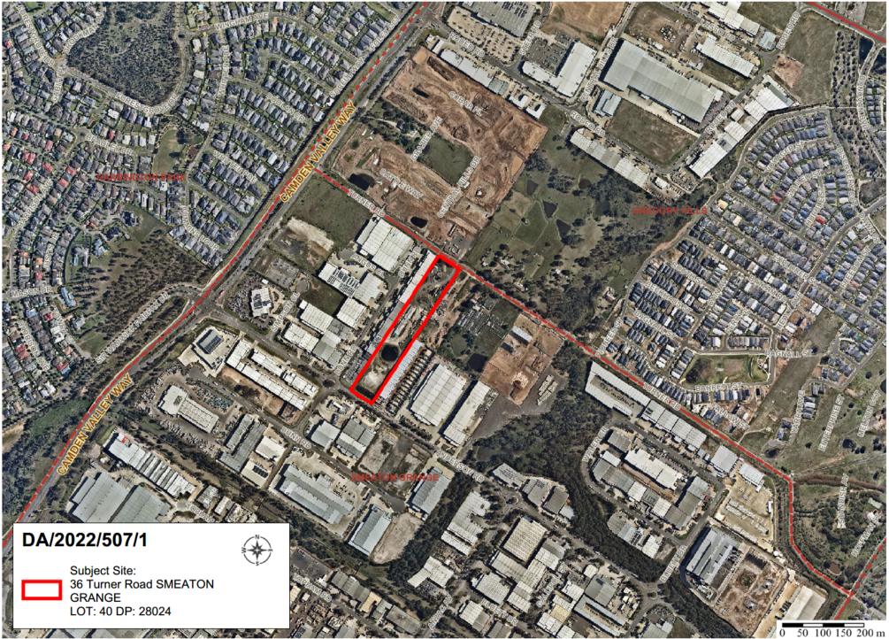

**THE SITE**

The site is commonly known as 36 Turner Road, Smeaton Grange and is legally described as Lot 40 in DP 28024 and has an area of 23,800m2. The site has recently been cleared which was subject to a previously approved DA. The site has a cross fall from north-west to south-east with a 13m fall across the site.

The site is located within the Smeaton Grange Industrial Precinct. The immediate surrounding area contains a range of industrial development and developing industrial sites. Immediately adjoining the site to the east is an industrial complex development that is currently under construction. To the south-west on the opposing side of Dunn Road is a service station and industrial tenancies, containing Tradelink (Plumbing supply business) and Wattyl Paint Centre on the sites to the north-west.

The surrounding locality to the north of the site is Gregory Hills which is currently undergoing transformation into an industrial/business precinct. Approximately 350m to the northeast is Gregory Hills residential area. Immediately surrounding the site to the east, south and west is the Smeaton Grange industrial area which has for the most part been developed, with a few vacant lots with approved industrial development. Further west, and on the opposite side of Camden Valley Way is Harrington Park residential area.

**ZONING PLAN**

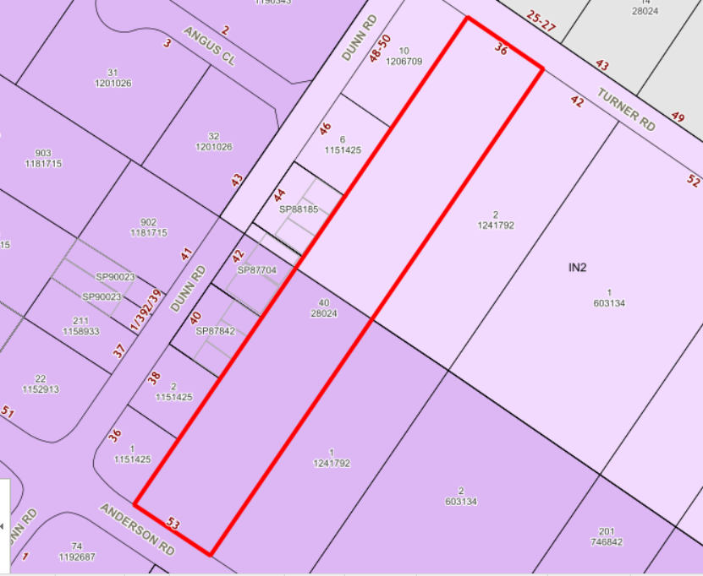

The site has a dual zoning being IN1 General Industrial comprising 48.53% of the site having a south-west orientation with road frontage to Anderson Road, and IN2 Light Industrial comprising 51.47% of the site with a north-eastern orientation with road frontage to Turner Road.

**HISTORY**

The relevant development history of the site is summarised in the following table:

|  |  |
| --- | --- |
| **Date** | **Development** |
| 20 May 2022 | Approval of DA/2022/81/1 for the demolition of existing structures, dewatering and removal of dams, vegetation removal. Construction of a temporary basin and earthworks/site regrading for future development site. |

**THE PROPOSAL**

DA/2022/507/1 seeks approval for the construction of a mixed use development comprising sixty-three (63) light industry units, self-storage premises, a centre-based child care centre for eighty (80) children, takeaway food and drink premises, ancillary manager's office, car parking, signage, landscaping and associated site works, specifically the development involves:

* Construction of a multi storey, multi podium development with a gross floor area (GFA) of 18,856m2 comprising:
* 63 light industrial units with mezzanines and a total GFA of 11,603m2 for use as Light Industry
* 159 self storage unit with a total GFA of 5,585m2
* An 80 place child care centre over two floors with a GFA of 1,167m2
* Ancillary office for use of site manager with a GFA of 75m2
* Takeaway food and drink premises with a GFA of 158m2
* Provision of 219 car parking spaces
* Two pedestrian bridges connecting the first floor of Podium 4 Part 1 and Podium 4 Part 3 from the South-East to North-West.
* Installation of lift on Podium 4 Part 2 connecting the first floor with the storage basement.
* Installation of two pylon signs
* Indicative signage
* Indicative solar system
* Associated site works including earthworks, drainage, services and landscaping
* operating hours of:
* Child care centre Monday – Friday 7am to 7pm
* The self-storage component of the site to operate 24 hours per day, 7 days a week.
* Operating hours for the light industrial units Monday – Friday 7am to 6pm
* The operating hours of the takeaway food and drink premises will be subject to separate development applications with their detailed first use approval
* The site is proposed to be enclosed by fencing and security gates, with the security gates being opened between the hours of 8am and 6pm. Tenants will have access to the site 24 hours by way of a swipe card entry system outside the opening hours

**PANEL BRIEFING**

Council staff briefed the DA to the Panel on 29 August 2022 and 17 October 2022. The following discussion provides an assessment of how the issues raised by the Panel at the briefing have been addressed.

Discussion items from 29 August 2022:

1. *The appropriateness of the location of the proposed child care centre.*

The applicant provided additional documentation including a Hazard Analysis Report in respect to the existing petrol station located at 1 Dunn Road, Smeaton Grange examining the proposed child care centre against the Preliminary Hazard Assessment (PHA) prepared in respect to the petrol station. The report determined the proposed child care centre was outside of the 55m sensitive use exclusion zone.

1. *The appropriateness of the design of the child care centre outdoor play space, particularly on level 1.*

Amended architectural plans have been provided deleting the proposed roof over the first floor outdoor play area and modifying the proposed awning roof for the ground floor play area. Amended landscaping plans have been provided which enhance the proposed landscaping treatment on the ground and first floor.

1. *The availability of the minimum solar access for the child care centre.*

The applicant provided a solar study that demonstrated that the development achieves compliance with the Child Care Planning Guidelines recommendation for a minimum of 2 hours solar access between the hours of 8:00am and 4:00pm during the winter solstice, for at least 30% of the required outdoor play space.

The solar study demonstrated hourly solar access plans for the proposed development on 21 June. The plans demonstrate the ground floor outdoor play area achieves the required solar access between 1:30pm and 3:30pm and the first floor outdoor play area achieves the required solar access between 9am and 11am.

1. *The data gaps in the contamination report*

A data gap analysis has been provided by the applicant that details additional contamination investigation following the completion of dam dewatering works, including additional sampling conducted in the portion of the site where the child care centre is proposed. The additional investigation indicated the elevated levels of arsenic identified in the original assessment could not be replicated. Based on sampling for the data gap analysis and previous investigations, the data gap analysis concluded the site in its entirety is suitable for the proposed use as commercial/industrial and as a child-care centre in the proposed location.

Council is satisfied the additional sampling, testing and data gap analysis addressed previous concerns.

1. *The potential exposure of the children to higher levels of pollution caused primarily by trucks entering and leaving the site.*

A data gap analysis to the Air Quality Assessment was provided detailing the impacts would have negligible risk and PM205 concentrations will not pose any unacceptable health risks to the child care centre from trucks entering, idling and/or exiting the site.

1. *The ability for the proposed child care centre to comply with the Education and Care Services National Regulations and the Child Care Planning Guidelines 2021.*

The amended plans provided by the applicant include the addition of clerestory windows to the first floor play space to provide additional natural light opportunities into the indoor play spaces.

The amended architectural plans, which delete the first floor roof structure to the outdoor play space, has alleviated previous concerns raised in respect to the validity of the area being described as an ‘outdoor play space’ and the questions of compliance with the Education and Care Services National Regulation.

1. *Consideration of the appropriateness of the proposed height exceedance across the centre of the site in conjunction with the consideration of locating the child care centre in the IN1 zone (fronting Anderson Rd), rather than the IN2 zone (fronting Turner Rd), which would be preferable.*

The proposed height exceedance in conjunction with the consideration of locating the child care centre in the IN1 zone fronting Anderson Road has been carefully considered during the assessment process.

The proposed height variation is discussed in depth later in this report. Furthermore, the potential relocation of the child care centre to the Turner Road frontage is considered relatively inconsequential. Although the site is zoned IN2 Light Industrial on the Turner Road frontage, the land opposite the site (on Turner Road) is zoned IN1 General Industrial under the SEPP (Precincts – Western Parkland City) 2021. Accordingly locating the child care centre on this frontage would have similar impacts than the currently proposed location.

It is considered locating the proposed development on the Anderson Road frontage is preferable as the surrounding land uses are established and there is certainty in terms of the assessment of existing / established land uses within the area. The applicant has provided reports prepared by suitably qualified professionals demonstrating the proposed location of the child care centre is suitable in terms of air quality, acoustics, contamination and traffic impacts.

The Transport and Infrastructure SEPP provides for additional considerations for child care centres in industrial zones (discussed in detail later in this report) to which the applicant has satisfied. In this regard, conditions of consent are recommended to ensure appropriate infrastructure is installed during the construction of the child care centre and conditions to ensure the ongoing safety of children and staff attending the centre. Council staff consider the proposed location of the child care centre to be suitable as proposed.

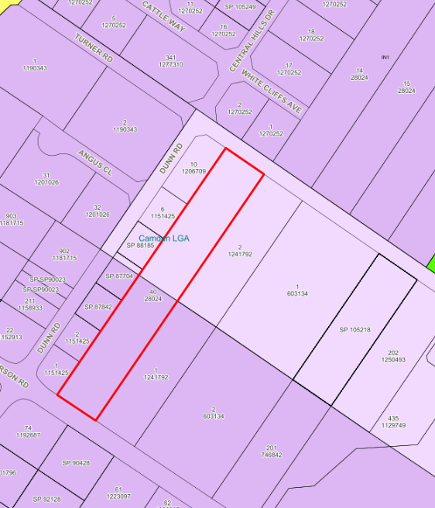

*Image 1- Additional land zoning context map*

Discussion items from 17 October 2022:

1. *It was noted that although potential conflicts with the child care centre, arising from surrounding existing and proposed uses, appear to have been resolved, it remains to be considered whether an approved child care centre may limit future industrial uses in the vicinity. The applicant’s representative advised that assessment criteria and related controls associated with the key concerns arising from potential industrial activities (eg. Acoustic or odour) would preclude conflicts. Nevertheless, this issue will need due consideration in finalizing the assessment report.*

As demonstrated throughout this report, the applicant has provided sufficient information, professional reports, and justification confirming the proposed child care centre can operate within the legislative framework and not cause adverse impact to existing or future industrial use of the area. The emerging use of the area is more akin to light industry as opposed to general industrial development. Council staff recommend support for the proposed child care centre in this locality.

**ASSESSMENT**

***Environmental Planning and Assessment Act 1979 - Section 4.15(1)***

In determining a DA, the consent authority is to take into consideration such of the following matters as are of relevance to the development the subject of the DA:

***(a)(i) the provisions of any environmental planning instrument***

The environmental planning instruments that apply to the development are:

* State Environmental Planning Policy (Planning Systems) 2021.
* State Environmental Planning Policy (Transport and Infrastructure) 2021.
* State Environmental Planning Policy (Resilience and Hazards) 2021.
* State Environmental Planning Policy (Industry and Employment) 2021.
* State Environmental Planning Policy (Biodiversity and Conservation) 2021.
* Education and Care Services National Regulation (2011 SI 653)
* Camden Local Environmental Plan 2010

State Environmental Planning Policy (Planning Systems) 2021 (Planning Systems SEPP)

The Planning Systems SEPP identifies development that is State significant and regionally significant development.

The Panel is the consent authority for this DA as the CIV of the development is $30,654,837 million. This exceeds the CIV threshold of $30 million for Council to determine the DA pursuant to Schedule 7 of the Planning Systems SEPP.

State Environmental Planning Policy (Transport and Infrastructure) 2021 (Transport and Infrastructure SEPP)

The Transport and Infrastructure SEPP aims to facilitate the effective delivery of infrastructure across the State.

***Endeavour Energy (Endeavour)***

The DA was referred to Endeavour for comment pursuant to Section 2.48 of the Transport and Infrastructure SEPP as the proposed development is within 5m of an exposed overhead electricity power lines.

Endeavour raised no objections to the development and recommended compliance with a number of technical guidelines and requirements. A condition requiring compliance with Endeavour’s technical guidelines and requirements is recommended.

***Early education and care facilities—specific development controls***

Pursuant to Clause 3.23, the consent authority must take into consideration any applicable provision of the Child Care Panning Guideline.

An assessment of the proposed development’s compliance with the provisions of the guidelines is attached to this report.

*Centre-based child care facility in Zone IN1 or IN2 - additional matters for consideration by consent authorities*

Pursuant to Clause 3.24, the consent authority must consider whether the proposed development is compatible with neighbouring land uses on land in IN1 General Industrial or IN2 Light Industrial.

The applicant has demonstrated (through the submission of extensive reports prepared by suitably qualified professionals) that the proposed child care centre will not negatively impact any of the existing industrial developments in the vicinity. Appropriate conditions of consent are recommended to ensure the child care centre is constructed in a manner (e.g. installation of air filtration systems, acoustic walls and the like) that ensures the ongoing safety of children, staff and visitors to the centre.

The consent authority must also consider the following matters before determining a development application for development for the purposes of a centre-based child care facility on land in Zone IN1 or IN2:

1. *Whether the proposed development is compatible with neighbouring land uses, including its proximity to restricted premises or hazardous land uses.*

The proposed child care centre will not be located near any restricted premises or sex services premises. While the child care centre is located adjacent to an existing service station (at 1 Dunn Road, Smeaton Grange), the applicant has provided a Hazard Analysis Report that concludes that the proposed child-care centre is outside of the 55m exclusion zone for sensitive land uses and therefore a suitable use for the proposed location.

1. *whether the proposed development has the potential to restrict the operation of existing industrial land uses.*

The proposed child care centre in this location will not detract from the industrial land uses in this vicinity and is consistent with the emerging land uses within this area (comprising mostly of light industrial activities). The child care centre will provide much needed child care facilities within the employment region of Smeaton Grange.

1. *whether the location of the proposed development will pose a health or safety risk to children, visitors or staff.*

This aspect of the application has been thoroughly considered as part of the assessment of this application. An initial Phase 2 Site Investigation (Contamination) assessment revealed an area of contamination on site however the report concluded the site was suitable for the ongoing use as a commercial/industrial site. As a child care centre is a more sensitive land use, a data gap analysis was conducted on the site which included further soil testing. The conclusion of this report detailed the site is suitable for the proposed industrial/commercial development and suitable for a child care centre in its proposed location.

An air quality assessment was provided in support of the proposed development. The assessment found that there are no existing industries in the vicinity of the proposed centre that are likely to cause adverse air quality impact on the sensitive receptor. The report identified a crematorium in Smeaton Grange located 600m from the proposed child care centre, which is sufficiently separated from the proposed child care centre to not cause any issues. The report recommended air intakes to be located away from driveways and the ducting contain additional air particulate filters. These recommendations form part of the recommended conditions of consent.

A data gap air quality analysis was provided examining the impacts of exhaust fumes from heavy vehicles entering and exiting the site, on the ground floor outdoor play space. The analysis concluded the impacts from this activity having a negligible risk and PM2.5 concentrations will not pose any unacceptable health risks to the child care centre.

As noted above, given the proximity of the child care centre to the existing service station at 1 Dunn Road, Smeaton Grange, the applicant provided a Hazard Analysis Assessment. The Hazard Analysis report determined a 55m exclusion zone is required from any LPG tank. The report determined the child care centre was located outside of the 55m sensitive use exclusion zone.

The acoustic report submitted provides an assessment of the existing background noise examined against the EPA requirements for noise limits for commercial and residential areas. Construction recommendations for the proposed development, including the use of 6.38mm glass for the proposed child care, form part of the recommended conditions of consent.

A supplementary letter was provided by the acoustic consultant discussing the potential impacts of surrounding industrial operational activity and the impact this may have on a sensitive receiver (child care centre). The report details in accordance with the recommendations of the AAAC, noise levels should not exceed 55dBA in the outdoor space. The location of the ground floor outdoor play space (being located approximately 9.5m from the kerb and the play space having an elevation of 1.2m above Anderson Road), coupled with the presence of an acoustic fence will ensure compliance with this control.

The adjacent industrial buildings, and those within the complex, are separated from the child care centre by external concrete walls with no openable windows/doors orientated toward the play areas and no external yard operation would generate high noise levels.

The additional report detailed it is unlikely the operational use within the neighbouring industrial buildings would be onerously restricted by the presence of the child care centre. Furthermore, provided the adjoining tenancies operate within their approved conditions, no adverse noise impact on the child care outdoor space is anticipated.

Council staff are satisfied that sufficient documentation, justification and information has been provided to demonstrate that there will be no negative impact on the health and wellbeing of children, staff or visitors to the child care centre.

Pursuant to Clause 3.26 the proposed child care centre is compliant with the Education and Care Services National Regulations (20211 SI 653) in that the proposed development is compliant with Clause 107 (indoor unencumbered space requirements) and Clause 108 (outdoor unencumbered space requirement) of the SEPP.

***Transport for NSW***

The application was referred to Transport for NSW (TfNSW) pursuant to State Environmental Planning Policy (Transport and Infrastructure) 2021, Schedule 3 as the application triggers the thresholds for traffic-generating development (car park with 200 car parking spaces). A response from TNSW has been received, with recommendations for the applicant to consult with the relevant bus operator regarding any potential impact to the bus stop at the site frontage on Anderson Road.

A condition of consent is recommended requiring compliance with the recommendations of this advice.

State Environmental Planning Policy (Resilience and Hazards) 2021 (Resilience and Hazards SEPP)

*Contaminated Land*

Section 4.6 of the Resilience and Hazards SEPP requires the consent authority to consider if the site is contaminated. If the site is contaminated, the consent authority must be satisfied that it is suitable in its contaminated state for the development. If the site requires remediation, the consent authority must be satisfied that it will be remediated before the land is used for the development. Furthermore, the consent authority must consider a preliminary contamination investigation in certain circumstances.

The applicant submitted a Phase 2 detailed contamination assessment. The results of this assessment detailed an area of elevated contamination (arsenic), however concluded the site was suitable for a commercial/industrial development. The report also concluded that there were areas of the site that were unable to be tested due to the existence of a dam on site.

Under a previous development consent the applicant was able to commence civil works on site, removing the dam and completing additional soil testing. A contamination data gap analysis was submitted which provided an assessment of further soil sampling in the location where the dam was formally located and over the area where the proposed child care centre is to be located. This assessment was unable to replicate the results where soil contaminants were previously discovered. The report concluded the site is suitable for the proposed land use as commercial/industrial generally as well as a child care centre in the proposed location.

Council staff are satisfied the site is suitable for the proposed use and no further investigation/remediation is required at this time.

A standard contingency condition is recommended that requires any contamination found during works to be managed with development consent obtained for remediation if required.

State Environmental Planning Policy (Industry and Employment) 2021 (Industry and Employment SEPP)

The application is seeking consent for the construction of the proposed pylon signs located at the central driveway entry on both the Anderson Road and Turner Road frontages. The remainder of the proposed signage provides indicative locations of signage throughout the site including the child care centre signage location, industrial unit business name location and the take away food and drink signage location.

An assessment of the proposed signage has not been undertaken as the proposed signage plans lack the required information for a complete assessment. A condition of consent is recommended requiring any proposed signage on site to comply with the requirements of the State Environmental Planning Policy (Exempt and Complying Development Codes) 2008 or a further development application will be required.

State Environmental Planning Policy (Biodiversity and Conservation) 2021 (Biodiversity and Conservation SEPP)

The Biodiversity and Conservation SEPP aims to protect the environment of the Hawkesbury-Nepean River system by ensuring that the impacts of future land uses are considered in a regional context.

The development is consistent with the aim of the Biodiversity and Conservation SEPP and all of its planning controls. There will be no detrimental impacts on the Hawkesbury-Nepean River system as a result of the proposed development. Appropriate erosion, sediment and water pollution control measures have been proposed as part of the development.

Education and Care Services National Regulations (2011 SI 653)

Division 1 and 2 of the Regulations apply to the proposed development being Centre-based services to which the proposed development is compliant. A complete assessment under the Regulations is attached to this report.

Camden Local Environmental Plan 2010

*Site Zoning*

The site has a dual zoning, being IN1 General Industrial (with road frontage to Anderson Road) and IN2 Light Industrial (with road frontage to Turner Road).

*Development Characterisation*

The development is characterised as a ‘centre-based child care facility’, a ‘takeaway food and drink premises’, ‘Light Industry’ units, and ‘self-storage’ units by the Camden Local Environmental Plan 2010.

*Permissibility*

The development is permitted with consent in the zones in which they are proposed pursuant to the land use table of the Camden Local Environmental Plan 2010.

*Planning Controls*

An assessment table in which the development is considered against the Camden Local Environmental Plan 2010 planning controls is provided as an attachment to this report.

*Proposed Contravention*

The applicant proposes a contravention to the height of buildings development standard that applies to the site. The development standard limits buildings to a maximum height of 11 metres above finished ground level. The proposed development will have a maximum height of 14.6m above finished ground level at the highest point. The contravention relates to the portion of the building located in the centre of the site and extends over both the IN1 and IN2 zones with the exceedance being located at the centre of the site.

*Contravention Assessment*

Pursuant to Section 4.6(3) of the Camden Local Environmental Plan 2010 (CLEP 2010), the applicant has submitted a written request that seeks to justify the contravention of the development standard. In summary, the applicant’s written request provides the following justification for the contravention:

* The proposed contravention will have no visual impact to the character on the existing streetscape due to the height exceedance being located in excess of 80m from either street frontage. The proposed building facades on either street frontage have a maximum height of 8.5m and due to the fall across the site, the frontages will obscure the view to the centre of the development where the height contravention is contained.
* The floor space ratio (FSR) for the proposed development is 0.792:1 with an allowable FSR of 1:1 under the CLEP 2010. The proposed height exceedance does not represent a development designed with excessive size and scale despite the height exceedance considering the proposed development provides an FSR below the maximum allowable for the site. The height exceedance enables a higher yielding development without compromising the maximum FSR, and without compromising the visual bulk of the building when viewed from the street.
* The contravention results from sloping topography and the concentration of the building along the eastern and western boundaries to provide a central driveway through the centre of the development, maximizing the proposed use of the site.
* The development has been designed to step with the topography of the land and is therefore mostly sympathetic to the slope of the site whilst providing level pads and ramp to result in a development that will be easier for the end user to navigate the site, including heavy-vehicles. Due to the stepping design of the proposed development the contravention is concentrated to the centre of the site. The proposed contravention will facilitate the orderly development and use of the land without adverse impact.

Pursuant to Clause 4.6(3) Development consent must not be granted for development that contravenes a development standard unless the consent authority has considered a written request from the applicant that seeks to justify the contravention of the development standard by demonstrating

(a) that compliance with the development standard is unreasonable or unnecessary in the circumstances of the case, and

(b) that there are sufficient environmental planning grounds to justify contravening the development standard.

The applicant has adequately identified that compliance with the development standard is unreasonable in the circumstances of the case and sufficient environmental planning grounds have been provided to justify contravening the development standard for the reasons detailed above and in the applicants Clause 4.6 Written Request attached to this report.

Pursuant to Section 4.6(4) of the Camden Local Environmental Plan 2010, Council staff are satisfied that:

* the applicant’s written request has adequately addressed the matters required to be demonstrated by Section 4.6(3) of the Camden Local Environmental Plan 2010, and
* the development will be in the public interest because it is consistent with the objectives of the particular standard and the objectives for development within the zones in which the development is proposed to be carried out.

The development standard contravention is supported for the following reasons:

* the development is consistent with the objectives of both the IN1 and IN2 zones which are discussed below:

Objectives of Zone IN1 General Industrial

1. *To provide a wide range of industrial and warehouse land uses.*

Comment: The proposed development will facilitate the construction and use of 63 light industrial units and 159 self storage units.

1. *To encourage employment opportunities*

Comment: The construction of the proposed development will provide a wide variety of employment opportunities to the locality including employment associated with light industry activities, child care workers and take-away food and drink employees which will benefit the local economy and provide varied jobs for the area.

1. *To minimise any adverse effect of industry on other land uses*

Comment: The proposed development is for light industry units which by definition do not interfere with the amenity of the neighborhood by reason of noise, vibration, smell fumes, vapor, soot, ash, dust, waste water, waste products, grit or oil, or otherwise. As detailed earlier in this report, suitable and sufficient documentary evidence prepared by suitably qualified professionals has been provided demonstrating the proposed child care centre will have no adverse impact on existing industrial activities and existing industrial activities will have no adverse impact on the proposed child care centre.

1. *To support and protect industrial land for industrial uses.*

Comment: The proposed development includes the proposed use of 63 industrial units (light industry) and 159 self-storage units. The proposed child care centre and takeaway food and drink premises are permissible uses within the zone and have been demonstrated throughout this report to be a positive contribution to the locality.

1. *To enable other land uses that provide facilities or services to meet the day to day needs of workers in the area.*

Comment: As detailed above, the proposed use of the site for light industry, self-storage units, take-away food and drink premises and child care centre provide for varied employment opportunities for the Smeaton Grange estate, provide additional and unique services to the area and will positively contribute to the local economy.

1. *To enable non-industrial land uses that are compatible with and do not detract from the surrounding industrial and warehouse land uses.*

Comment: The proposed child care centre and take away food and drink premises will provide employees of the complex and the greater Smeaton Grange Industrial Estate with much needed child care for the area. The proposed take away food and drink premises will provide employees of the complex and local adjoining development with food options within close proximity to their place of work and eliminate the need to travel into Gregory Hills or Narellan to purchase lunch which will positively contribute to the local area. As detailed throughout this report, sufficient documentary evidence has been provided demonstrating the proposed child care centre is compatible with the existing and emerging land uses within the local area.

Objectives of Zone IN2 Light Industrial

1. *To provide a wide range of light industrial, warehouse and related land uses.*

Comment: The proposed development is for the construction and use of the 63 Industrial units for the purpose of Light industry and therefore facilitating the objectives of the zone.

1. *To encourage employment opportunities and to support the viability of centres.*

Comment: The proposed employment opportunities on the site facilitate the use of the site for the purposes of light industry operations, childcare and take away food and drink employment. The proposed development will positively contribute to the character and viability of this area of Smeaton Grange and provide a street presence on both Turner Road and Anderson Road with the entirety of the 2.38ha site proposed to be developed under this application.

1. *To minimise any adverse effect of industry on other land uses.*

Comment: As detailed throughout this report, the proposed development will contribute positively to the locality and will have no adverse impact on the neighboring developments.

1. *To enable other land uses that provide facilities or services to meet the day to day needs of workers in the area.*

Comment: The proposed developments are permissible within the zone.

1. *To support and protect industrial land for industrial uses.*

Comment: The proposed development is compatible with land use zones to which comprehensive assessment has been provided throughout this report. The proposed uses of the site are permissible within the zone. The proposed height contravention will have no negative impact on this objective.

1. *To enable non-industrial land uses that are compatible with and do not detract from the surrounding industrial and warehouse land uses.*

Comment: The proposed development including the proposed childcare centre will have no negative impact on the IN1 or IN2 zones as discussed comprehensively throughout this report. The proposed height contravention will have no negative impact on the existing surrounding developments and the overall development will positively contribute to the Smeaton Grange estate.

1. *To minimise the impacts of development on surrounding residential or other sensitive land uses.*

Comment: The site is located within the Smeaton Grange industrial estate and located in excess of 350m from the nearest residential dwelling located within Gregory Hills. The proposed development is not located near any sensitive landuses.

* the development is consistent with the objectives of Clause 4.3 Height of Buildings development standard:

1. *To ensure that buildings are compatible with the height, bulk and scale of the existing and desired future character of the locality.*

Comment: The height exceedance is concentrated to the centre of the site with a maximum height of 14.6m. Due to the sloping topography of the site and the building being designed in steps, the maximum building height varies from 11.7m to 14.6m with all exceedances being located in the centre of the site. The height exceedance has a setback from the Turner Road boundary of 197m and 128m from Anderson Road boundary.

There are a number of examples of developments within Smeaton Grange where building height variations have been supported, including:

* DA/2013/602/1 - 65 Anderson Road, Smeaton Grange for the construction of three industrial units with a maximum height of 14.725m was approved on 28/11/2013.
* DA/2010/68/1 – 34 Dunn Road, Smeaton Grange for the construction of industrial building with a maximum height of 15.75m was approved on 28/01/2011.
* DA/2011/598/1 - 21-33 Dunn Road, Smeaton Grange for the construction of two industrial buildings with a maximum height of 17m was approved on 27/10/2011.
* DA/2012/371/1 – 2-10 Dunn Road, Smeaton Grange for the construction of industrial building with a maximum height of 16.7m was approved on 11/12/2012.
* DA/2014/83/1 – 95-97 Anderson Road, Smeaton Grange for the construction of a warehouse building with a maximum height of 17.03m was approved on 02/05/2014.

The height exceedance for the proposed development will have no negative visual impact at street level due to the sloping topography and stepped design of the proposed development. The height exceedances are centralised on the site, and the areas to which the height exceedances occur are obscured by existing buildings.

The proposed development distributes the bulk of the buildings along the eastern and western boundaries with the proposed buildings being stepped to accommodate the fall of the site. The centralised driveway creates a visual break in the buildings when viewed from the street. The portion of the buildings located along each frontage have a maximum height of 8.5m fronting Anderson Road and 8m fronting Turner Road. This provides appropriate building context from street level with these portions of the building being below the maximum permissible building height of 11m.

1. *To minimise the visual impact, disruption of views, loss of privacy and loss of solar access to existing development.*

Comment: The proposed building height contravention will have no adverse visual impact to the street and will not disturb views or create a loss of privacy or solar access.

1. *To minimise the adverse impact of development on heritage conservation areas and heritage items.*

Comment: There are no heritage items or heritage conservation areas within the locality.

Clause 4.6(4) requires Development consent must not be granted for development that contravenes a development standard unless –

1. The consent authority is satisfied that –
2. the applicant’s written request has adequately addressed the matters required to be demonstrated by subclause (3).

Comment: The applicant has adequately address the matters required to be demonstrated by subclause 3 as discussed above and contained within the applicants Clause 4.6 request as attached to this report.

1. the proposed development will be in the public interest because it is consistent with the objectives of the particular standard and the objectives for development within the zone in which the development is proposed to be carried out.

Comment: As detailed in the assessment above, the proposed development is consistent with the objectives of Clause 4.3 Height of Buildings and the objectives of both the IN1 and IN2 zones.

Consequently, it is recommended that the Panel support this proposed contravention to the Camden Local Environmental Plan 2010.

***(a)(ii) the provisions of any proposed instrument that is or has been the subject of public consultation under this Act and that has been notified to the consent authority (unless the Secretary has notified the consent authority that the making of the proposed instrument has been deferred indefinitely or has not been approved)***

Draft Environment State Environmental Planning Policy (Draft Environment SEPP)

The development is consistent with the Draft Environment SEPP in that there will be no detrimental impacts upon the Hawkesbury-Nepean River system as a result of it.

Draft Remediation of Land State Environmental Planning Policy (Draft Remediation of Land SEPP)

The development is consistent with the Draft Remediation of Land SEPP in that it is consistent with the Resilience and Hazards SEPP.

***(a)(iii) the provisions of any development control plan***

Camden Development Control Plan 2019 (Camden DCP)

*Planning Controls*

An assessment table in which the development is considered against the Camden DCP is provided as an attachment to this report.

*Proposed Variation – Car Parking*

The applicant proposes a variation to Section 2.18.2 of the Camden DCP regarding off-street car parking provision.

The Camden DCP base car parking rates equate to 233 off-street car parking spaces for the development as follows:

* Take away food and drink premises = 12 spaces per 100m² = 158m2 / 100 x 12 = 18.96
* Warehouse or Distribution Centre / Storage Premises = 1 space per 300m² = 5585m2 / 300 = 18.61.
* Industry / Light industry =
  + 1 space per 70m² = 9,505m² / 70 = 135.78.

Office space is calculated for mezzanine areas in excess of 20% of the GFA of the industrial unit at the rate for Office Premises and Business Premises.

* 1 space per 70m2 = 1426 / 70 = 20.37
* 1 space per 40m2 = 672 / 40 = 16.8
* Child Care Centre = 1 space per 4 children = 80 children / 4 = 20
* Office = 1 space per 40m2 = 75 / 40 = 1.8
* Total spaces = 232.32 (233) spaces.

The applicant proposes to provide 219 spaces (a 14 space deficit on the base rates).

The applicant has submitted a detailed parking submission in support of the DA which includes the following justification:

* The car parking rate required in the DCP for the takeaway food and drink premises is more suitable to a fast-food outlet.
* The nature of the proposed food and drink premises is to serve the employees of the complex and immediate surrounds rather than be a destination location and accordingly the majority of patrons are likely to arrive by foot.

*Variation Assessment*

Council’s Traffic Engineer has assessed the applicant’s parking submission and undertaken an analysis of the car parking demands of the development (with consideration of the layout of the development) and supporting documentation provided for the proposed development. It is recommended that reduced car parking rates be supported for the following reasons:

* It is considered appropriate to apply the car parking shortfall to the take away food and drink premises as this aspect of the development is designed to be utilised by existing workers / visitors to the site.
* The applicant’s justification concerning the take away food and drink premises servicing existing workers / visitors to the site is supported. There is a lack of food and drink premises within the locality and it is considered the take away food and drink premises will be frequented by employees of the complex.
* As the proposed food and drink premises is proposed to be take away in nature, this will reduce gathering at the premises and reduce the premises desirability as a destination location.
* As a take away food and drink premises any visiting customers to the site will provide a high turnover and therefore the number of car parking spaces required to service this component of the development will be reduced.
* The carparking shortfall represents a 6% variation and is considered a minor variation to the requirements of the control.

Consequently, it is recommended that the Panel support this proposed variation to the Camden DCP.

***(a)(iiia) the provisions of any planning agreement that has been entered into under section 7.4, or any draft planning agreement that a developer has offered to enter into under section 7.4***

No relevant planning agreement or draft planning agreement exists or has been proposed as part of this DA.

***(a)(iv) the regulations (to the extent that they prescribe matters for the purposes of this paragraph)***

The *Environmental Planning and Assessment Regulation 2021* prescribes several matters that are addressed in the conditions attached to this report.

***(b) the likely impacts of the development, including environmental impacts on both the natural and built environments, and social and economic impacts in the locality***

As demonstrated by the assessment, the development is unlikely to have any unreasonable adverse impacts on either the natural or built environments, or the social and economic conditions in the locality.

***(c) the suitability of the site for the development***

As demonstrated by the assessment, the site is considered to be suitable for the development.

***(d) any submissions made in accordance with this Act or the regulations***

The DA was publicly exhibited for a period of 14 days in accordance with Camden Community Participation Plan 2021. The exhibition period was from 22 June 2022 to 5 July 2022 and no submission were received.

***(e) the public interest***

The public interest is served through the detailed assessment of this DA under the *Environmental Planning and Assessment Act 1979*, the *Environmental Planning and Assessment Regulation 2021*, environmental planning instruments, development control plans and policies. Based on the assessment, the development is consistent with the public interest.

**EXTERNAL REFERRALS**

The external referrals undertaken for this DA are summarised in the following table:

|  |  |
| --- | --- |
| **External Referral** | **Response** |
| Transport for NSW. | Recommendations for the proponent to consult with the relevant bus operator regarding any potential impact to the bus stop at the site frontage on Anderson Road. |
| Endeavour Energy. | No objection and conditions recommended. |
| Camden Police Area Command. | No objection and conditions recommended. |

Conditions from external referral recommendations will be imposed

**FINANCIAL IMPLICATIONS**

This matter has no direct financial implications for Council.

**CONCLUSION**

The DA has been assessed in accordance with Section 4.15(1) of the *Environmental Planning and Assessment Act 1979* and all relevant instruments, plans and policies. The DA is recommended for approval subject to the conditions attached to this report.

**RECOMMENDED**

**That the Panel:**

1. **support the applicant’s written request lodged pursuant to Section 4.6(3) of Camden Local Environmental Plan 2010 to the contravention of the height of buildings development standard in Section 4.3 of the Camden Local Environmental Plan 2010, and**
2. **approve DA/2022/507/1 for the construction of a mixed use development comprising sixty-three (63) light industry units, self-storage premises, a centre-based child care centre for eighty (80) children, takeaway food and drink premises, ancillary manager's office, car parking, signage, landscaping and associated site works at 36 Turner Road, Smeaton Grange, subject to the conditions attached to this report.**